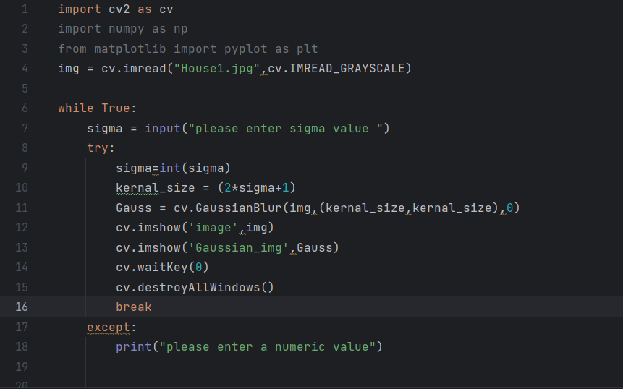

Question 1 A :

Page 1

Page 2

Σ = 1

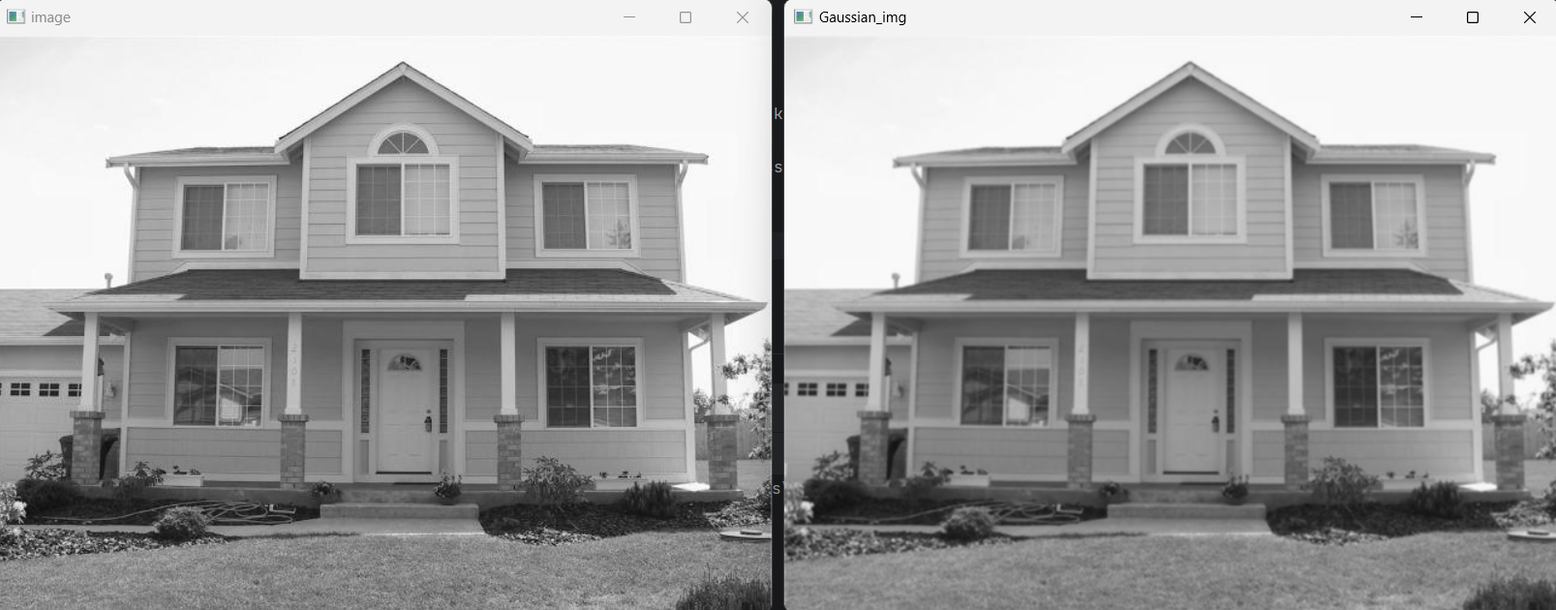

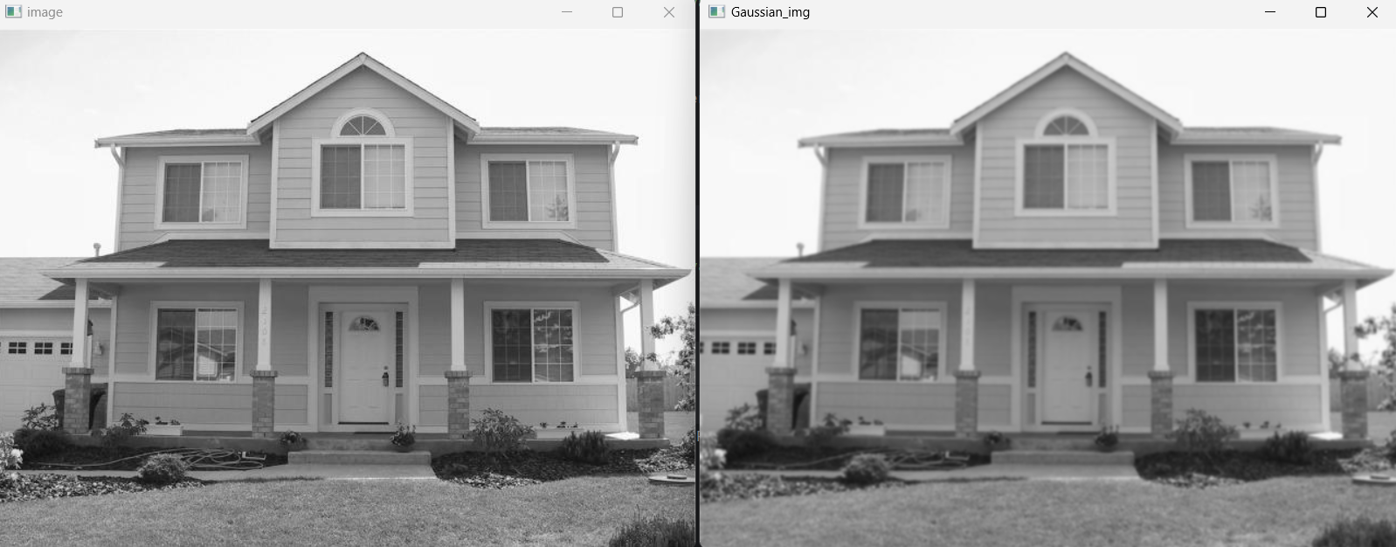

Σ = 2

Page 2

Σ = 3

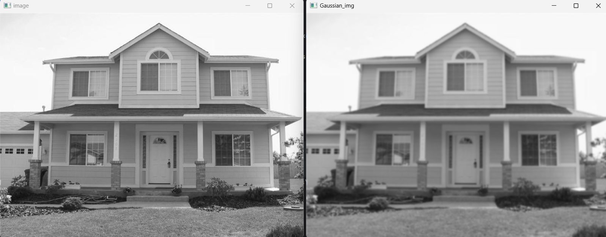

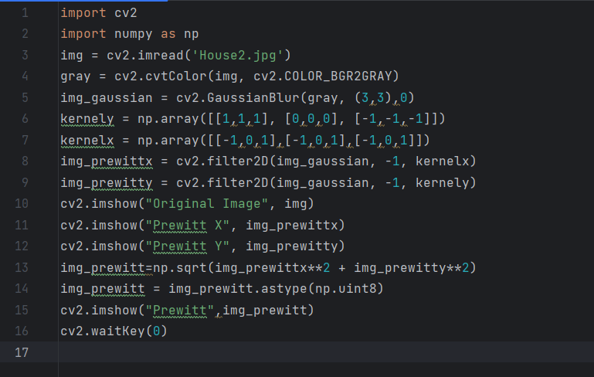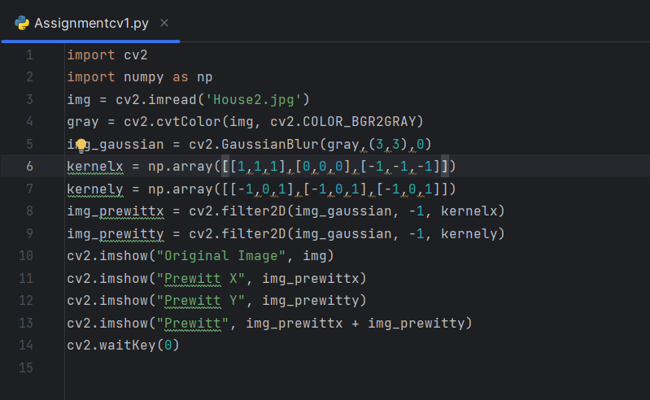

Question 1 B :

Page 3





Page 4





Page 5



Question 2 :

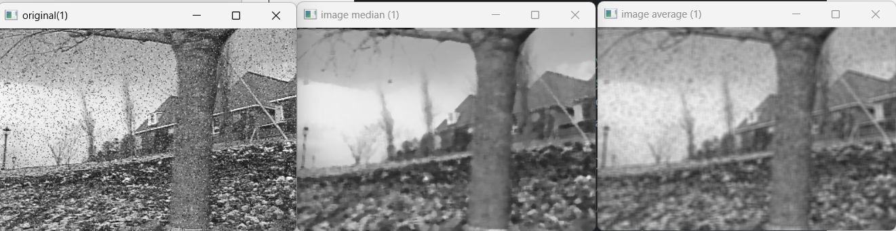

Page 6





Page 7



The median filter is much better at retaining sharp edges than the average filter because the median value must really be the value of one of the pixels in the neighborhood rather than a new, irrational value when the filter straddles an edge.

Page 9

Page 10

Question 3:

Page 11

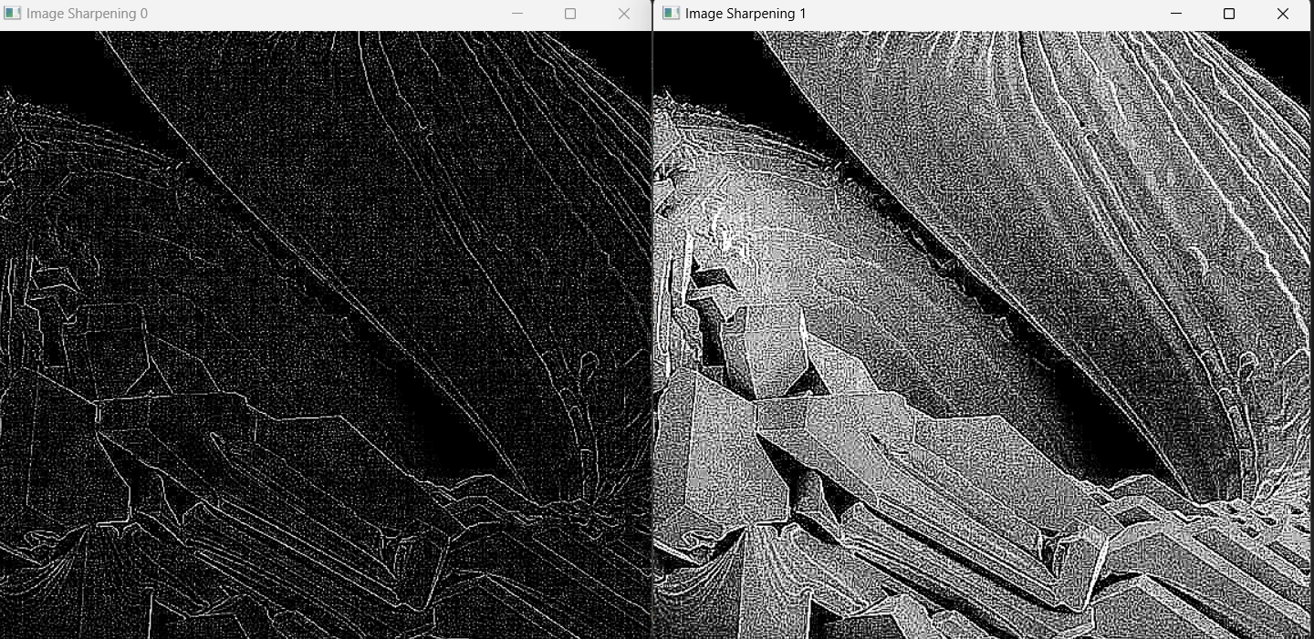



Page 11

Question 4:



High boost filtering produces a lot of pixels with values when is large, making it sharper.

High boost, then, is a kind of sharpening that accentuates high-frequency elements that reflect visual information without removing low-frequency elements